

**PROJECT REPORT ON**

**QUERY GENERATOR**

**(Automation of Access Provisioning)**

**FOR APP SUPPORT MS OBIEE**

**OF**

**BMS**

**Submitted by RAHUL KAMBLE**

**Through**

**PRADEEP KRISHNAN M**

* **PROBLEM STATEMENT:**

Currently the OBIEE access provisioning team performs a repetitive task of editing INSERT queries to provide access to users of the application.

* This method is prone to manual errors that lead to false entries in the database.
* This method is time consuming due to manual cross checking of the attributes example: Every role has a different module and license group which can only be checked from the database.
* **PROPOSED SOLUTION:**

Query generator is a GUI tool developed using Python scripting language. It aims to overcome the above mentioned problems.

* Using this tool the values for required attributes in the INSERT queries can be filled with a GUI form as shown below.

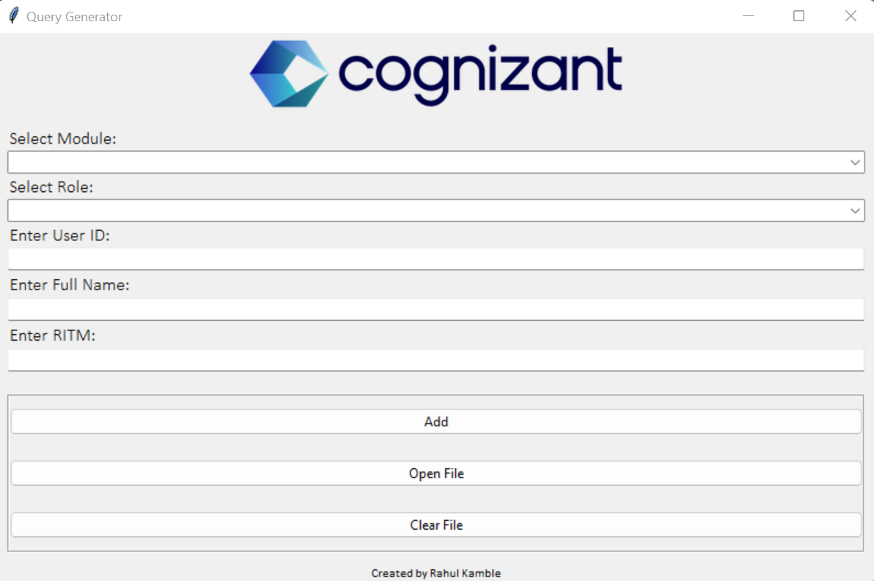

* After selection of a module from the first list box, we can view/select all the roles present in that respective module from the second list box as shown below.



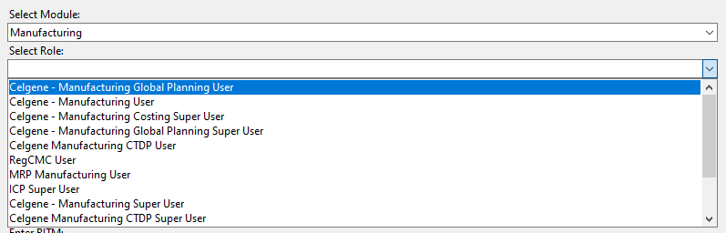

* After entering all required details and clicking on “Add” a query will automatically be produced in an output text file which can be viewed by clicking on “Open File”.

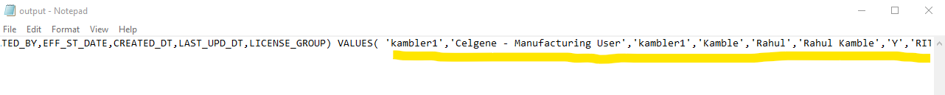

* The values can be changed as many times as needed and clicking on “Add” will append a new query at the end of the file.
* Finally clicking on “Clear File” will erase all queries and make the output file ready for its next run.

* **SOFTWARE SELECTION:**
* **Language:** Python
* **Version:** 3.10.1
* **SCOPE OF THE SOLUTION:**

**This tool now requires database connectivity to pull all Module records.**

* With database connectivity instead of query generation entire access provisioning itself can be automated
* User deactivation activity can similarly be added to this tool as an add on function
* One click assistance to OBIEE URLs / documents can be added as a functionality
* A GUI tool is easy to operate and may prove useful for people with minimal SQL knowledge.
* This tool will particularly prove to be useful when a single user requires multiple roles.
* It will improve the speed and accuracy of data while editing queries.